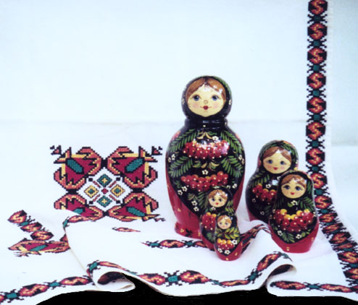
Holy Trinity Russian Orthodox Church
1723 E. Fairmount Ave.
Baltimore, MD 21231

HOLY TRINITY RUSSIAN ORTHODOX CHURCH

RUSSIAN FESTIVAL SOUVENIR PROGRAM BOOK

Oct. 14, 15, 16

ADVERTISING CONTRACT FORM

DEADLINE SEPTEMBER 25, 2016

AD SIZE COST TOTAL

Inside front cover (5½ x8 ½) $250 B&W ____ ___
Inside back cover (5½ x8 ½) $250 B&W _______
Back cover (5½ x8 ½) $300 B&W _____ __
Full page (5½ x8 ½) $100 _______
Half page (5½x4 ¼) $ 55 _______
One third page/ Business card (2½x4 ¼ ) $ 25 _______
Patron (up to two lines) $ 10 _______
In Memory (up to two lines) $ 10 _______

Prices are with artwork or layout ready to print.
There will be an additional charge of $10.00 to create artwork for print.
Type or print message in the box below or attach camera-ready ad to this sheet.

Name (please print) ____________________________________________________________

Company/ organization: _________________________________________________________

Address: _____________________________________________________________________

_____________________________________________________________________

Phone: _______________ Fax: _______________ Email: ____________________________

Amount enclosed: ____________________

Make checks payable to Holy Trinity Russian Festival.
Mail to Russian Festival, 4042 Stansbury Mill Rd., Monkton, Md. 21111

For more information contact Michael Mickel at 410-666-2870 or mcmickel@verizon.net

